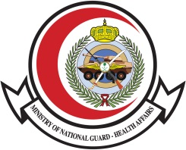

Time | Topic | Objectives |  | Speakers
9.00 -9.15 | Introduction
9.15-9.45 | Epidemiology of HIV |  | Dr.Mohamad BoSaeed
9.45-10.15 | Natural history and Diagnosis of HIV infection |  | DR.Abdulrahman Al Saeedy
10.15-10.45 | Cases scenarios in AIDS opportunistic infection |  | Dr.Ahmad Al Harbi
10.45-11.00 | Break
11.00-11.30 | Treatment of HIV infection and other opportunistic infection |  | Dr. Ibrahim Mahmoad
11.30-1200 | Antiretroviral drugs overviews (classes, Side Effects and Drug – Drug Interaction) |  | Dr.Mohamad Al Essa
12-12.30 | The emotional aspect and stigmatization |  | Dr. Yousra Alatig
12.30-1300 | Public health role in HIV management |  | Ms.Eman Almazroa
1300-13.05 | closing |  | Dr..Majid Al Shamrani
Ministry of National Guard-Health Affairs
Infection Prevetnion and Control Program

World HIV Day Program

Date : Sunday, December 12th , 2019
Time : 08:00 a.m. – 01:00 p.m.
Venue : Sammer Bin Huraib large Auditorium

